# LEARNMATE

# A PROJECT REPORT

**for**

**Mini Project-II (ID201B)**

**Session (2024-25)**

**Submitted by**

**Anshu Nisad (202410116100032)**

**Chitransha Bhath (202410116100056)**

**Disha Seth (202410116100064)**

**Ayushi Saran Singh(202410116100047)**

**Submitted in partial fulfilment of the Requirements for the Degree of**

MASTER OF COMPUTER APPLICATION

**Under the Supervision of**

**Dr. Vipin Kumar**

**Associate Professor**



**Submitted to**

**Department Of Computer Applications**

**KIET Group of Institutions, Ghaziabad**

**Uttar Pradesh-201206**

**(MAY- 2025)**

# CERTIFICATE

Certified that **ANSHU NISHAD (202410116100032), CHITRANSHA BHATT (202410116100054), DISHA SETH (202410116100064), AYUSHI SHARAN SINGH (202410116100047)** has/have carried out the project work having “**LEARNMATE**.” (**Mini Project-II, ID201B**) for **Master of Computer Application** from Dr. A.P.J. Abdul Kalam Technical University (AKTU**)** (formerly UPTU), Lucknow under my supervision. The project report embodies original work, and studies are carried out by the student himself/herself and the contents of the project report do not form the basis for the award of any other degree to the candidate or to anybody else from this or any other University/Institution.

**Dr. Vipin Kumar Dr. Akash Rajak**

**Associate Professor Dean**

**Department of Computer Applications Department of Computer Applications KIET Group of Institutions, Ghaziabad KIET Group of Institutions, Ghaziabad**

**ABSTRACT**

In the era of digital learning, personalized education is transforming how students, educators, and institutions engage with study materials. LearnMate is a cutting-edge SaaS application that leverages Gemini AI to automate the creation of study resources, quizzes, and summaries tailored to individual learning needs. This platform enhances efficiency by providing customized content, reducing manual effort for educators, and offering students a seamless, adaptive learning experience.

The application is built on a scalable and serverless architecture, ensuring efficiency and performance. The frontend is developed using React and Next.js, ensuring an interactive and optimized UI, while Tailwind CSS enhances responsiveness. The backend operates on Neon (PostgreSQL-based), providing a robust data storage solution. AI-generated materials are powered by Gemini AI, enabling dynamic and contextual study resource generation. Clerk ensures secure authentication, while Stripe supports subscription-based monetization. Workflow automation is handled by Inngest, optimizing background tasks and improving efficiency.

By integrating AI-driven content generation with modern web technologies, LearnMate aims to revolutionize the education sector by offering a personalized, scalable, and automated learning experience. The platform is designed to cater to both individual learners and institutions, ensuring accessibility, engagement, and knowledge retention.

Keywords: Personalized Learning, AI-powered Education, Study Material Automation, SaaS for Learning, Adaptive Learning

# ACKNOWLEDGEMENTS

Success in life is never attained single-handedly. My deepest gratitude goes to my project supervisor, Dr. Vipin Kumar for his guidance, help, and encouragement throughout my project work. Their enlightening ideas, comments, and suggestions. Words are not enough to express my gratitude to Dr. Akash Rajak, Professor and Dean, Department of Computer Applications, for his insightful comments and administrative help on various occasions. Fortunately, I have many understanding friends, who have helped me a lot in many critical conditions. Finally, my sincere thanks go to my family members and all those who have directly and indirectly provided me with moral support and other kinds of help. Without their support, completion of this work would not have been possible in time. They keep my life filled with enjoyment and happiness.

**ANSHU NISHAD**

**CHITRANSHA BHATT**

**DISHA SETH**

**AYUSHI SHARAN SINGH**

# TABLE OF CONTENTS

|  |  |
| --- | --- |
| Certificate | ii |
| Abstract | iii |
| Acknowledgement | iv |
| Table of Contents | v |
| 1 Introduction | 6-7 |
| 1.1 Overview |  |
| 1.2 Project Description | 6 |
| 1.3 Project Scope | 6 |
| 1.4 Objectives | 7 |
| 1.5 Purpose |  |
| 2 Feasibility Study | 8-10 |
| 2.1 Technical feasibility | 8 |
| 2.2 Economic feasibility | 8 |
| 2.3 Operational feasibility | 10 |
| 2.4 Legal Feasibility |  |
| 2.5 Schedule Feasibility |  |
| 3 Project Objective | 11 |
| 4 Hardware and Software Requirements | 13 |
| 5 Project Flow | 14 |
| 6 Project Outcome | 24 |
| Conclusion |  |
| References | 59 |

**CHAPTER 1: INTRODUCTION**

The rapid advancements in artificial intelligence (AI) have significantly transformed various industries, including education. Traditional learning methods often struggle to provide personalized study experiences, leading to inefficiencies in knowledge retention and engagement. To address this, LearnMate is designed as a cutting-edge SaaS platform that leverages Gemini AI to generate customized study materials, quizzes, and summaries tailored to individual learning needs.

LearnMate aims to automate and enhance the study process for students, educators, and institutions by providing AI-driven content that adapts to different learning styles. The platform ensures a seamless and scalable educational experience by integrating serverless architecture, an optimized UI, and AI-powered learning resources.

This project utilizes modern web technologies such as React, Next.js, and Tailwind CSS for a responsive and interactive interface, while Neon (PostgreSQL-based) serves as a robust data management system. Secure authentication is ensured through Clerk, while Stripe enables subscription-based monetization. Workflow automation is handled by Inngest, ensuring smooth operations.

By merging AI-driven content creation with an intuitive and scalable platform, LearnMate revolutionizes the learning experience, making education more accessible, engaging, and efficient for a diverse range of users.

* 1. **Overview**

**LearnMate** is a next-generation educational platform that redefines the way students learn and educators teach by integrating the power of artificial intelligence with modern web technologies. As the demand for personalized and efficient learning tools continues to grow, LearnMate positions itself as an innovative solution that bridges the gap between traditional education methods and modern technological advancements. This AI-powered SaaS application is designed to serve students, educators, and academic institutions by offering a dynamic and personalized learning experience that is not only user-friendly but also scalable and impactful.

At its core, LearnMate is built to simplify and personalize the learning journey. Students often face challenges when trying to find reliable, concise, and easy-to-understand study materials, especially when under tight deadlines or navigating complex subjects. Similarly, educators are frequently burdened with the repetitive task of creating lesson content, quizzes, and revision notes for various topics. LearnMate solves both problems by leveraging Gemini AI to generate high-quality, context-aware study resources and assessments. With just a few inputs, the platform can produce comprehensive topic explanations, concise summaries, and custom quizzes that adapt to the user’s academic level and intent. This empowers learners to access precisely what they need without sifting through irrelevant information or outdated notes.

The personalized aspect of LearnMate is one of its strongest features. Unlike generic educational websites or content repositories, LearnMate uses AI to tailor content generation based on the user's preferences, subject area, and depth of knowledge. Whether a student is preparing for an entrance exam, brushing up on a specific concept, or just starting out on a new topic, the platform ensures that the generated content is aligned with their learning goals. For educators, this means they can deliver high-quality, individualized materials without spending hours preparing documents manually. The result is a streamlined, more effective teaching and learning process that can scale across classrooms and institutions.

From a technical standpoint, LearnMate is built with a modern and robust tech stack. The frontend of the platform utilizes React.js and Next.js, offering a fast, responsive, and intuitive user interface. Tailwind CSS is employed to design a clean and consistent visual experience that remains accessible across all devices. The backend follows a serverless architecture, powered by Inngest, to ensure that content generation and data processing are handled efficiently and asynchronously. This not only improves the platform’s performance but also makes it highly scalable and cost-effective, especially for large user bases or growing institutions.

User authentication and security are handled through Clerk, a scalable authentication service that supports role-based access control, social logins, and secure session management. This ensures that users can safely access their accounts, track their progress, and manage their subscriptions without any technical barriers. Speaking of subscriptions, LearnMate features a monetization model integrated with Stripe. This enables flexible subscription plans where users can choose from free and premium tiers based on their learning needs and budget. Free users get access to core features with certain limitations, while premium subscribers enjoy extended AI responses, advanced content generation, and priority support.

What truly sets LearnMate apart is its AI integration. Gemini AI, known for its ability to generate coherent, human-like content, serves as the brain of the platform. It analyzes user inputs—whether they be questions, topics, or entire syllabi—and delivers educational content that is both accurate and pedagogically sound. Unlike other AI tools that may generate verbose or irrelevant answers, LearnMate fine-tunes its AI prompts to align closely with academic expectations, making it ideal for school and college-level learners. The quizzes it generates are also intelligently crafted, with varying levels of difficulty, diverse question types, and the option to provide instant feedback, which reinforces learning.

* 1. **Project description**

In an age where education is rapidly evolving and technology is becoming deeply integrated into learning systems, traditional methods of teaching and studying often fall short in meeting the diverse needs of modern learners. Students today require fast, personalized, and contextually relevant content to support their learning journeys, while educators seek tools that can help them create, manage, and distribute educational material more efficiently. With this vision in mind, **LearnMate** was developed — an intelligent, AI-powered SaaS platform that revolutionizes the way students learn and teachers teach by offering a seamless, personalized, and scalable solution.

**LearnMate** is a full-stack web application designed to serve as a smart learning companion for students and an efficient content creation tool for educators. The project is built around the core idea of making quality education more accessible, customizable, and interactive. Leveraging **Gemini AI**, LearnMate is capable of generating personalized study notes, comprehensive explanations, topic-wise summaries, and interactive quizzes — all tailored to individual learning levels and goals. Whether a user is revising a chapter, preparing for an exam, or simply exploring a new subject, LearnMate adapts to their needs and delivers instant support.

The application addresses two major gaps in the current education landscape. First, it helps students save time by eliminating the need to browse through multiple resources for study material. Instead, they can generate accurate and structured content with just a topic input. Second, it assists educators by automating the repetitive and time-consuming task of content creation, such as drafting notes, summaries, or quizzes. This allows teachers to focus more on instruction and student interaction, rather than content preparation.

From a technical perspective, LearnMate is built using a robust and modern stack. The frontend of the application is developed using **React.js** and **Next.js**, ensuring high performance and a smooth user experience. The design is crafted with **Tailwind CSS**, which offers flexibility and responsiveness, making the platform accessible across desktops, tablets, and smartphones. The backend follows a **serverless architecture** using **Inngest**, enabling asynchronous operations like content generation and event-driven workflows. This makes the application more scalable, cost-effective, and responsive to user actions.

Authentication and user management are handled by **Clerk**, which offers a secure and developer-friendly solution for login, registration, and role-based access. Users are divided into roles such as students, educators, and administrators, each with personalized access to features relevant to their needs. For monetization, **Stripe** is integrated into the platform to handle subscription payments. LearnMate follows a freemium model, where basic functionality is free and advanced features are unlocked through paid plans. This model supports sustainable growth while keeping the core functionality accessible to a wide user base.

The standout feature of LearnMate is its **Gemini AI integration**. It is the backbone of the platform’s smart capabilities. When a user enters a topic or keyword, the AI processes the input and generates high-quality content — whether it’s a detailed explanation of a historical event, a summary of a scientific concept, or a quiz on programming basics. The AI is fine-tuned to understand educational contexts, ensuring that the output is academically appropriate and easy to comprehend. Additionally, quizzes generated by LearnMate include varying levels of difficulty, multiple-choice questions, and instant feedback, which makes self-assessment effective and engaging.

LearnMate is not limited to individuals. It holds significant potential for use in academic institutions, coaching centers, and online learning platforms. Institutions can use LearnMate to distribute uniform study content, reduce the manual workload on faculty, and provide students with AI-generated revision material that aligns with their syllabus. Future updates may include analytics dashboards to track student performance, progress monitoring, and group learning modules, further enhancing its institutional relevance.

The platform is hosted on **Vercel**, ensuring fast deployments, high uptime, and smooth scalability. With its serverless architecture, LearnMate can handle a growing number of users without compromising on performance. The application’s interface is clean, minimal, and intuitive, making it easy for users of all age groups and technical backgrounds to engage with the platform. It is built with accessibility and user experience at its core, ensuring that every user can navigate and benefit from the platform without a steep learning curve.

In terms of development approach, the project followed agile methodology with regular testing and iteration cycles to ensure that both performance and usability goals were met. Key challenges included ensuring content accuracy from AI, managing user roles effectively, and creating a subscription model that balances monetization with value delivery. These were addressed through iterative design, user feedback, and careful tuning of AI prompts and serverless workflows.

* 1. **Project scope**

**LearnMate** is an AI-integrated SaaS platform designed to transform the educational experience by offering personalized learning solutions to students, educators, and institutions. The project focuses on utilizing the capabilities of **Gemini AI** to generate customized study materials, summaries, and quizzes, making education more accessible, efficient, and tailored to individual learning needs. The scope of the project covers the design, development, deployment, and maintenance of the platform, along with integration of essential features such as user authentication, subscription plans, and AI-powered content generation.

The primary objective of LearnMate is to streamline the study process for students and assist educators in creating quality content effortlessly. The platform allows students to input a topic and instantly receive well-structured notes, detailed explanations, and concise summaries. It also enables them to test their understanding through automatically generated quizzes. For educators, LearnMate serves as a time-saving tool that reduces the workload associated with preparing study materials, while also offering options to create and distribute content more efficiently.

The scope includes the development of a responsive and user-friendly interface using **React.js**, **Next.js**, and **Tailwind CSS**, ensuring that users across all devices can access the platform with ease. The backend is built on a **serverless architecture using Inngest**, allowing scalable and event-driven handling of AI tasks and user interactions. This architectural choice ensures that LearnMate remains lightweight, flexible, and capable of handling a growing user base without significant infrastructure challenges.

User management is a key component of the project, handled securely through **Clerk**. Users are segmented into different roles—students, educators, and administrators—each with access to specific features. A **Stripe-based subscription system** is included in the scope to enable monetization of the platform, offering both free and premium access tiers. Free users are given limited access to AI responses and quiz features, while premium users benefit from advanced content generation, longer responses, and priority support.

The AI component, powered by **Gemini AI**, is at the heart of LearnMate’s functionality. The AI is responsible for interpreting user inputs and generating context-aware content that matches the user’s academic level and learning preferences. Ensuring the accuracy, readability, and relevance of this content is within the project’s scope, along with continuous fine-tuning and prompt optimization.

The scope also includes deploying the platform using **Vercel**, ensuring continuous integration and smooth updates. Additionally, testing, debugging, user feedback collection, and future updates for analytics dashboards and performance tracking are considered part of the project’s long-term scope.

In summary, the scope of LearnMate encompasses the development of a full-stack AI-powered learning platform that delivers personalized content, offers secure user access, includes a flexible subscription model, and supports scalability and future enhancements. The project is designed to not only meet current educational needs but also adapt to future demands in the EdTech space.

* 1. **Objectives**

The primary objective of the **LearnMate** project is to build a smart, scalable, and user-centric educational platform that leverages artificial intelligence to transform how students learn and how educators deliver content. With the increasing need for personalized, on-demand learning resources and the growing adoption of digital education tools, LearnMate aims to bridge the gap between traditional learning systems and modern technology-driven education. The platform is designed to empower students with instant access to AI-generated study materials and help educators streamline content creation, thus fostering a more efficient, engaging, and inclusive learning experience.

Here are the key objectives of the LearnMate project, explained in detail:

1. **To personalize the learning experience using AI:** LearnMate integrates **Gemini AI** to analyze user input—whether it's a topic, keyword, or concept—and generate customized content including detailed explanations, concise summaries, and adaptive quizzes. The objective is to provide learners with study material that aligns with their academic level, learning pace, and individual goals.
2. **To automate content creation for educators:** Teachers often spend a significant amount of time preparing notes, quizzes, and lesson plans. LearnMate simplifies this process by allowing educators to auto-generate educational content within seconds. This improves teaching efficiency and frees up time for interactive and meaningful engagement with students.
3. **To build a responsive and modern web application:** Using technologies like **React.js**, **Next.js**, and **Tailwind CSS**, LearnMate aims to offer a smooth and responsive user experience across desktops, tablets, and smartphones. The objective is to make the platform intuitive and easy to use for all types of users, regardless of their technical expertise.
4. **To implement a secure authentication and user management system:** LearnMate uses **Clerk** for secure sign-up, login, and role-based access control. The goal is to ensure a personalized and protected experience for users by distinguishing between students, educators, and administrators, each having role-specific features and dashboard access.
5. **To provide flexible subscription-based access to features:** The platform integrates **Stripe** to offer a **freemium model**—where users can access core features for free and unlock advanced functionalities through paid plans. This makes the platform scalable, sustainable, and accessible to users with varying needs and budgets.
6. **To support scalability through serverless architecture:** By utilizing **Inngest** for serverless event handling, LearnMate ensures asynchronous AI processing, real-time content generation, and efficient performance, even under high user load. This ensures the platform remains stable and scalable as the user base grows.
7. **To enhance student engagement through interactive learning:** LearnMate generates AI-powered quizzes with instant feedback, allowing learners to assess their understanding of topics. This interactive approach promotes better retention and encourages self-paced, confidence-building study habits.
8. **To enable future integration of analytics and tracking features:** The project is designed with future scalability in mind, where institutions and users will be able to monitor progress, usage, and performance trends through analytics dashboards and learning insights.
   1. **Purpose**

The purpose of LearnMate is to revolutionize the way students learn and educators teach by using artificial intelligence to create a more personalized, efficient, and accessible learning environment. In today’s fast-paced digital world, traditional one-size-fits-all educational approaches often fail to meet the unique needs of every learner. LearnMate was conceived as a smart solution to this problem — a platform where technology meets education to provide real-time, relevant, and customized learning content with just a few clicks.

At its core, LearnMate aims to simplify the learning journey for students by enabling them to generate study materials instantly. Whether it’s a detailed explanation of a concept, a summarized version of a complex topic, or a self-assessment quiz, students can rely on LearnMate to deliver content tailored to their academic level and learning speed. This on-demand support empowers students to take control of their studies, overcome knowledge gaps, and prepare more effectively for exams or classwork.

Equally important is LearnMate’s role in supporting educators. Teachers often face challenges in preparing content for different learning styles, creating assessments, and managing time. LearnMate lightens this burden by offering AI-generated resources that can be used as classroom material, revision notes, or personalized assignments. By reducing manual content creation, the platform allows educators to focus more on meaningful interaction and instruction, rather than repetitive tasks.

LearnMate also addresses the modern need for inclusive and accessible education. With a responsive design and intuitive UI built using modern web technologies like React, Next.js, and Tailwind CSS, the platform is easy to use across devices and accessible to students from different backgrounds, regardless of technical ability. Additionally, by incorporating both free and premium access through Stripe-powered subscriptions, LearnMate ensures that quality education is within reach for everyone — not just those who can afford expensive resources or coaching.

Another key purpose of the platform is to encourage self-paced, independent learning. Many students struggle in traditional classrooms where the pace of teaching doesn’t align with their grasping ability. LearnMate solves this by allowing learners to access content anytime, revisit summaries, and test themselves through quizzes tailored to their level. It promotes a growth mindset where students can learn through exploration, trial, and feedback.

From a technical perspective, LearnMate is designed for scalability and future growth. Built on a serverless architecture using Inngest, the platform handles AI tasks efficiently and asynchronously, ensuring smooth performance even with a growing user base. With authentication handled by Clerk, user data is kept secure, and role-based access ensures a personalized experience for each user type — student, educator, or admin.

# CHAPTER 2 : FEASIBILITY STUDY

It evaluates whether a project is viable from various perspectives before significant resources are invested. It involves assessing technical, economic, and operational factors to ensure the project's success. Here's an explanation of the aspects covered in the feasibility study for the LearnMate:

* 1. **Technical feasibility :-**
     1. **Technologies Overview**

The LearnMate will utilize modern web technologies to ensure efficient performance and compatibility across platforms:

**Core Technologies :**

* **React.js**React.js will be the core library for building the frontend of LearnMate. As a powerful and widely adopted JavaScript library, React.js is ideal for building dynamic user interfaces. Its component-based architecture ensures that the application’s interface is modular, maintainable, and highly performant.
* **Next.js**LearnMate will be built using Next.js, a popular React framework for server-side rendering (SSR) and static site generation (SSG). Next.js enables fast page loading, improved SEO, and optimized performance, making it perfect for a content-heavy platform like LearnMate**.**
* **TailwindCSS**Tailwind CSS will be used to create a responsive and modern UI design for LearnMate. This utility-first CSS framework allows for rapid design and prototyping.
* **Stripe**Stripe will be integrated for payment processing, enabling LearnMate to implement a subscription-based monetization model.
  + 1. **System Architecture**

The LearnMate system architecture follows a modern, scalable, and efficient design that integrates several components to ensure a seamless user experience.

1. **Frontend (Client-Side):**
   * Developed using React.js and Next.js for dynamic UI and fast server-side rendering.
   * Responsive design ensures compatibility across desktop, tablet, and mobile devices.
2. **Backend (Serverless Architecture):**
   * Powered by Inngest, LearnMate uses serverless functions to handle content generation, user management, and subscription logic.
   * Event-driven architecture enables scalability without the need for traditional server management.
3. **AI-Powered Content Generation (Gemini AI):**
   * Gemini AI generates personalized study notes, summaries, and quizzes based on user input.
   * Machine learning models ensure content relevance according to the learner’s level and needs.
4. **User Authentication and Role Management (Clerk):**
   * Clerk handles secure user authentication, registration, and role-based access.
   * Ensures students, educators, and admins have tailored access and data security.
5. **Payment and Subscription Management (Stripe):**
   * Stripe manages subscriptions, payments, and billing for both free and premium users.
6. **Hosting and Deployment (Vercel):**
   * Hosted on Vercel, ensuring fast global delivery and automatic scaling.
     1. **Security Measures**

Security is paramount given the sensitive nature of the communication. Key measures include:

**1. Authentication & Authorization (Clerk)**

* LearnMate uses Clerk for secure user authentication and role-based access control.
* Role-based access ensures students, educators, and admins can only access features specific to their permissions.

**2. Data Encryption**

* All user data transmitted between the client and server is secured using HTTPS with TLS (Transport Layer Security) encryption.
* Sensitive data stored on servers (e.g., passwords, tokens) are encrypted using industry-standard algorithms to prevent unauthorized access.

**3. Secure Payments (Stripe Integration)**

* Payment details are never stored on LearnMate servers, ensuring financial data is handled with maximum security and compliance.

**4. Serverless Security (Inngest)**

* The serverless backend ensures that each function runs in isolation, minimizing the attack surface.
* Rate-limiting and input validation are implemented to prevent abuse and injection attacks.

**5. AI Safety Measures (Gemini AI)**

* All AI-generated content is monitored and filtered to avoid offensive, inappropriate, or misleading information.
* Prompts are sanitized before processing to reduce risks of prompt injection or adversarial inputs.

**6. Monitoring & Logging**

* Real-time activity logs and alerts are maintained to track suspicious behaviour or unauthorized access attempts.
* Continuous monitoring tools ensure system health, uptime, and incident response readiness.
  + 1. **Development Considerations**

**Development Tools:**

* **Visual Studio Code –** Main code editor with extensions for React and Tailwind.
* **Git & GitHub –** Version control and collaborative code management.
* **Postman –** API testing and validation.
* **Figma –** UI/UX prototyping and design.
* **Vercel CLI –** For seamless deployment and hosting.
* **Stripe Dashboard –** Subscription and payment integration testing.
  1. **Economic feasibility**

**2.2.1 Cost Analysis**

A thorough economic analysis identifies various cost components relevant to the development and maintenance of the API:

* **Development Costs:** Personnel (developers, project managers): Estimated at $100,000 for the team over six months. Infrastructure (servers, databases): Initial setup costs around $10,000.
* **Operational Costs:** Hosting services (AWS, Google Cloud): Approximately $100/month initially.

**2.2.2 Marketing & Outreach**

* **Initial Marketing (Social Media, Ads**) : Optional, but a small marketing campaign might cost ₹2,000–₹5,000.
* **Branding Assets (Logo, Banners):** If designed externally, may cost ₹1,000–₹3,000.

**2.2.3 API & AI Integration**

* **Gemini AI (by Google):** Depending on usage volume, API costs may start from free tier to ₹1,000–₹5,000/month for higher usage.
* **Stripe:** No upfront cost; deducts a small fee per successful transaction (usually ~2.9% + ₹3 per transaction).
  + 1. **Pricing Strategy**
* **Freemium Model:** Basic service free, with advanced features available through subscription plans.
* **Pricing Tiers:** Individual users: $5/month, Business users: $20/month for enhanced features like larger message limits and additional security measures.

**2.3. Operational feasibility**

**2.3.1 User Experience**

* **User Interface (UI):** Simple, intuitive design that requires minimal training.
* **User Journey:** Streamlined process for creating and retrieving messages.

**2.3.2 Implementation Strategy**

* **Phased Rollout:** Begin with a pilot program among select users to gather feedback and make improvements.
* **Marketing Plan:** Utilize content marketing, social media, and partnerships to promote the LearnMate.

**2.3.3 Support and Maintenance**

* **Technical Support:** Establish a support team for user inquiries and issues.
* **Continuous Updates:** Regularly introduce new features based on user feedback and technology advancements.

**2.3.4 Adoption Factors**

* **Learning Curve:** Ensure onboarding materials (tutorials, FAQs) are easily accessible.
* **Feedback Mechanism:** Encourage user feedback for continuous improvement, fostering a community around the API.

**2.4. Legal feasibility**

Legal feasibility involves evaluating the LearnMate project in terms of compliance with applicable laws, regulations, and data protection standards. Since LearnMate operates as a SaaS-based educational platform that collects, processes, and stores user data—including personal information and payment details—legal compliance is crucial for ensuring trust, preventing liabilities, and enabling smooth operation across regions.

**2.4.1. Data Privacy and Protection**

LearnMate collects data such as user names, email addresses, learning preferences, and potentially location-based data. It is therefore essential to comply with data privacy regulations such as:

* **General Data Protection Regulation (GDPR)** – For any users from the European Union, LearnMate ensures transparent data usage policies, the right to access and delete data, and consent-based data processing.
* **Information Technology Act, 2000 (India) –** LearnMate complies with Indian regulations on data protection, cyber laws, and digital transactions.

**2.4.2 Intellectual Property Considerations**

All content generated by Gemini AI within LearnMate is original and unique to the user’s request. However, safeguards are placed to prevent misuse of copyrighted content or plagiarized material. Additionally:

* All code written for LearnMate is original or built on properly licensed open-source libraries.
* LearnMate’s branding (including logos, UI designs, and name) is registered or protected under copyright or trademark laws to avoid misuse or duplication.

**2.4.3 Payment Security (PCI Compliance)**

Since LearnMate integrates Stripe for handling financial transactions, it inherits the PCI-DSS (Payment Card Industry Data Security Standard) compliance provided by Stripe. This ensures secure handling of all payment-related data without storing any sensitive card information on LearnMate's servers.

**2.5. Schedule feasibility**

Schedule feasibility evaluates whether the LearnMate project can be completed within a reasonable and planned timeframe using available resources. Since timely delivery is crucial for educational platforms—especially those catering to exam preparation, semesters, or academic calendars—careful planning of each development phase is essential. The project follows an agile development methodology, allowing flexibility while maintaining structured progress toward milestones.

* + 1. **Development Timeline**

Below is the proposed development timeline for LearnMate, broken down into phases:

* Phase 1: Requirements Gathering and Planning (2 months)
* Phase 2: Architecture and Design (1 month)
* Phase 3: Development and Implementation (3 months)
* Phase 4: Testing (1 month)
* Phase 5: Deployment and User Feedback (1 month)

**2.5.2 Milestones and Deliverables**

* Milestone 1: Complete requirements documentation by Month 2.
* Milestone 2: Finish the API architecture and design by Month 3.
* Milestone 3: Complete development by Month 6.
* Milestone 4: Complete testing and deploy by Month 7.

# CHAPTER 3 : PROJECT OBJECTIVES

## 3.1 introduction

In today’s digital era, education is undergoing a significant transformation driven by the integration of artificial intelligence and smart learning systems. The demand for personalized, accessible, and efficient learning solutions has never been higher. Traditional teaching methods and static content delivery models often fail to address the diverse learning needs of individual students, while educators are burdened with repetitive content creation tasks and administrative responsibilities. This has highlighted the need for intelligent systems that not only support learners with instant, personalized resources but also empower educators by automating routine tasks and improving instructional efficiency.

The project titled **LearnMate** aims to address these challenges by creating a web-based, AI-powered learning platform that provides on-demand, customized study content to students and teaching tools to educators. It leverages advanced AI models—specifically **Gemini AI**—to generate topic-specific study notes, concise summaries, and interactive quizzes, all tailored to the user's level of understanding and educational needs.

This chapter outlines the **objectives** that guide the design, development, and implementation of LearnMate. These objectives are aligned with the broader goal of enhancing educational quality, accessibility, and personalization through technology. By establishing clear research and development goals, this project seeks to contribute a practical solution to ongoing issues in the education sector, specifically in the fields of content generation, learner engagement, and adaptive learning.

## User Authentication and Security

* **Enhance Data Security Through Encryption**

**Objective:** The primary objective of this feature is to ensure that all user information—including personal data, login credentials, and user activity—is protected using industry-standard encryption protocols. This helps in preventing unauthorized access, data breaches, and misuse of sensitive information.

**Details:**

By implementing strong encryption techniques, LearnMate aims to:

* Safeguard user identities and login credentials through hashed passwords and secure token management.
* Protect data in transit using **HTTPS with TLS (Transport Layer Security)**, ensuring that communication between client and server remains encrypted and unreadable to third parties.

## Benefits:

## Ensures Authorized Access Only - Encryption safeguards sensitive user data—such as login credentials, personal information, and usage history—by making it unreadable to unauthorized entities. Even if data is intercepted, it remains protected, ensuring confidentiality and integrity.

### ****User Trust and Credibility****

A secure platform fosters trust among users. When learners and educators know their data is protected, they are more likely to engage confidently with the platform and recommend it to others.

* **Data Integrity and Confidentiality -** Encryption during both storage and transmission guarantees that messages cannot be read or altered by anyone other than the intended recipient.

### ****Secure Financial Transactions****

With encryption and secure authentication in place, payment information processed via **Stripe** is handled safely. This reduces the chances of financial fraud and supports PCI-DSS compliance.

* **One-Time Access Protection -** Messages can only be viewed once. After that, they are destroyed, eliminating the possibility of replay attacks or future breaches.
* **Encrypted Communication with HTTPS -** All data is transmitted over HTTPS, protecting it from interception and man-in-the-middle (MITM) attacks.

1. **Create unique, encrypted links**

**Objective:**

The main objective of generating **unique, encrypted links** in LearnMate is to ensure secure, user-specific access to sensitive resources such as:

* Personalized study materials
* AI-generated summaries and quizzes
* Time-limited access to shared content (e.g., assignments, tests)
* One-time login or invitation links for onboarding

Each link is generated dynamically and includes encrypted parameters (e.g., user ID, content ID, timestamp) to prevent tampering or unauthorized access. These links can be encoded using encryption algorithms such as **AES-256** or **JWT (JSON Web Tokens)** to preserve confidentiality and validity.

**Benefits:**

**1. Secure Content Sharing**

Encrypted links prevent users from accessing content not intended for them, safeguarding personalized educational resources.

**2. Time-Bound Access**

Links can be set to expire after a specific duration or after one use—ideal for time-sensitive resources like tests or live classes.

**3. Prevent Unauthorized Distribution**

Since each link is user-specific and encrypted, it can’t be freely shared or reused by others—protecting intellectual property and ensuring that access is controlled.

**4. Trackability**

Each link can be tracked to the specific user who accessed it, allowing educators and administrators to monitor resource engagement and prevent misuse.

**5. Enhanced User Experience**

Users receive direct access to the exact material they need without needing to log in again or search manually—improving usability while maintaining security.

**6. Simplified Onboarding**

Encrypted invitation links can be used to register new users, assign them roles (e.g., student or teacher), and direct them to pre-configured dashboards, making onboarding smooth and secure.

1. **Minimize the Attack Surface**

The objective of minimizing the attack surface is to reduce the number of entry points or vulnerabilities within the LearnMate platform that malicious actors can exploit. This involves strategically identifying, securing, and restricting unnecessary or overly broad access within the system, ensuring that only legitimate users and services can interact with critical resources.

By minimizing the attack surface, LearnMate aims to:

* Protect user data and system integrity from external threats.
* Reduce the potential impact of a security breach.
* Ensure that sensitive actions (such as payment processing, AI content generation, and user data modification) are only available to authorized users.

# 1 . Hardware requirements

# CHAPTER 4 : HARDWARE/SOFTWARE REQUIREMENTS

* **For Developers (Development Environment)**

To build and test LearnMate efficiently, developers need systems capable of running modern frameworks, local servers, and cloud-integrated workflows.

| **Component** | **Minimum Requirement** | **Recommended** | **Purpose** |
| --- | --- | --- | --- |
| **Processor (CPU)** | Intel i5 7th Gen / Ryzen 5 | Intel i7 / Ryzen 7 | Smooth performance for builds, compilation, and serverless function testing |
| **RAM** | 8 GB | 16 GB or higher | To handle simultaneous services (Node.js, frontend dev server, DB client) |
| **Storage** | 256 GB SSD | 512 GB SSD | Faster dependency installations, local builds, and caching |
| **Graphics** | Integrated GPU | Dedicated GPU (optional) | Not mandatory unless working on AI locally; Gemini AI is cloud-based |
| **Internet** | 20 Mbps (minimum) | 50 Mbps or higher | For seamless cloud API access (Gemini, Clerk, Stripe, Neon, Inngest) |

* **For End Users (Students, Educators)**

As a SaaS platform, LearnMate is optimized to run on low-spec devices via a browser. It’s designed to be responsive and lightweight.

| **Device** | **Smartphone, Tablet, Laptop or Desktop (any OS)** |
| --- | --- |
| **RAM** | Minimum 2 GB (for mobile), 4 GB (for PC/laptop) |
| **Browser** | Latest version of Chrome, Firefox, Safari, or Edge |
| **OS** | Android 8+, iOS 12+, Windows 10+, macOS 10.15+, or any modern Linux |
| **Internet Speed** | Minimum 2 Mbps (Recommended: 10 Mbps for dynamic content loading) |

1. **Software Requirements**

**Operating System Compatibility**

* **Development:** Cross-platform (Windows, macOS, Linux)
* **Deployment:** Serverless – no OS dependency (cloud infrastructure)
* **Development & Build Tools**

| **Tool** | **Use Case** |
| --- | --- |
| **Node.js (v16+)** | Runs backend APIs and frontend dev server (Next.js) |
| **npm / Yarn** | Package managers to install project dependencies |
| **VS Code** | Preferred code editor with integrated terminal, Git, and extension support |
| **Git & GitHub** | Version control, team collaboration, CI/CD integration |
| **Vercel CLI** | Deploy and preview serverless Next.js applications |

* **Frontend Technologies**

| **Technology** | **Purpose** |
| --- | --- |
| **React.js** | Component-based UI development for scalability and maintainability |
| **Next.js** | Framework for routing, server-side rendering, static generation, API routes |
| **Tailwind CSS** | Utility-first CSS for fast, responsive, mobile-friendly styling |
| **Clerk UI Kit** | Plug-and-play components for login, signup, profile UI |

* **Backend & API**

| **Tech** | **Purpose** |
| --- | --- |
| **Next.js API Routes** | Serverless backend endpoints (user actions, content requests, Stripe logic) |
| **Inngest** | Handles background jobs asynchronously (e.g., quiz generation, email notifications) |
| **Neon DB (PostgreSQL)** | Cloud-hosted, scalable, serverless SQL database for all structured content |
| **Lib/Utils** | Custom logic for AI prompt handling, user roles, response formatting |

* **AI Integration: Gemini AI**

| **Component** | **Purpose** |
| --- | --- |
| **Gemini API (Google AI)** | Generates summaries, flashcards, quizzes from user input dynamically |
| **Prompt Handler** | Sends well-structured instructions to Gemini for consistent output |
| **Study Type Routes** | Fetches AI-generated content based on user’s selected learning mode |

*Gemini AI ensures learning content is dynamically personalized, context-aware, and continuously updated.*

* **Authentication & Security: Clerk**

| **Feature** | **Role** |
| --- | --- |
| **OAuth Logins** | Google, GitHub sign-in support |
| **Multi-Factor Auth (MFA)** | Adds security via OTP or secondary email verification |
| **Session Management** | Secure cookies, token refreshing, and persistent login |
| **Role-Based Access** | Distinguishes between users (students, educators, admins) |

*Clerk eliminates the need to build authentication from scratch and provides enterprise-level security out-of-the-box.*

* **Payments & Subscriptions: Stripe**

| **Integration** | **Use** |
| --- | --- |
| **Stripe Checkout** | Secure UI for one-time and recurring payments |
| **Billing Management** | View, cancel, or update user subscriptions |
| **Webhook Events** | Automatically updates user access after payment success/failure |

*Stripe allows LearnMate to operate as a monetized SaaS with premium feature tiers.*

* **Workflow Automation: Inngest**

| **Functionality** | **Purpose** |
| --- | --- |
| **Background Jobs** | Asynchronous processing (e.g., generating large documents, email notifications) |
| **Event Triggers** | Executes actions when a user starts a course or requests material |
| **Retry Mechanism** | Automatically retries failed operations without interrupting the user flow |

*Inngest ensures users don’t have to wait for all content at once—data loads as it's generated.*

* **Cloud Deployment & Hosting: Vercel**

| **Vercel Features** | **Role in LearnMate** |
| --- | --- |
| **Serverless Functions** | Scales automatically with demand |
| **Instant Preview Links** | Shareable links for testing and staging |
| **Continuous Deployment** | Auto-deploys latest GitHub code commits |
| **Custom Domains + SSL** | Professional hosting with HTTPS enabled |

* **Environment Configuration**

A .env.local file is used to securely store all API keys and secrets:

* CLERK_SECRET_KEY
* STRIPE_SECRET_KEY
* GEMINI_API_KEY
* NEON_DATABASE_URL
* INNGEST_API_KEY

*This ensures sensitive credentials are never hard-coded and are managed securely.*

**CHAPTER 5 : PROJECT FLOW**

**5.1 Flowchart**

Flowchart is a diagrammatic representation of sequence of logical steps of a program.Flowcharts use simple geometric shapes to depict processes and arrows to show relationships and process/data flow.

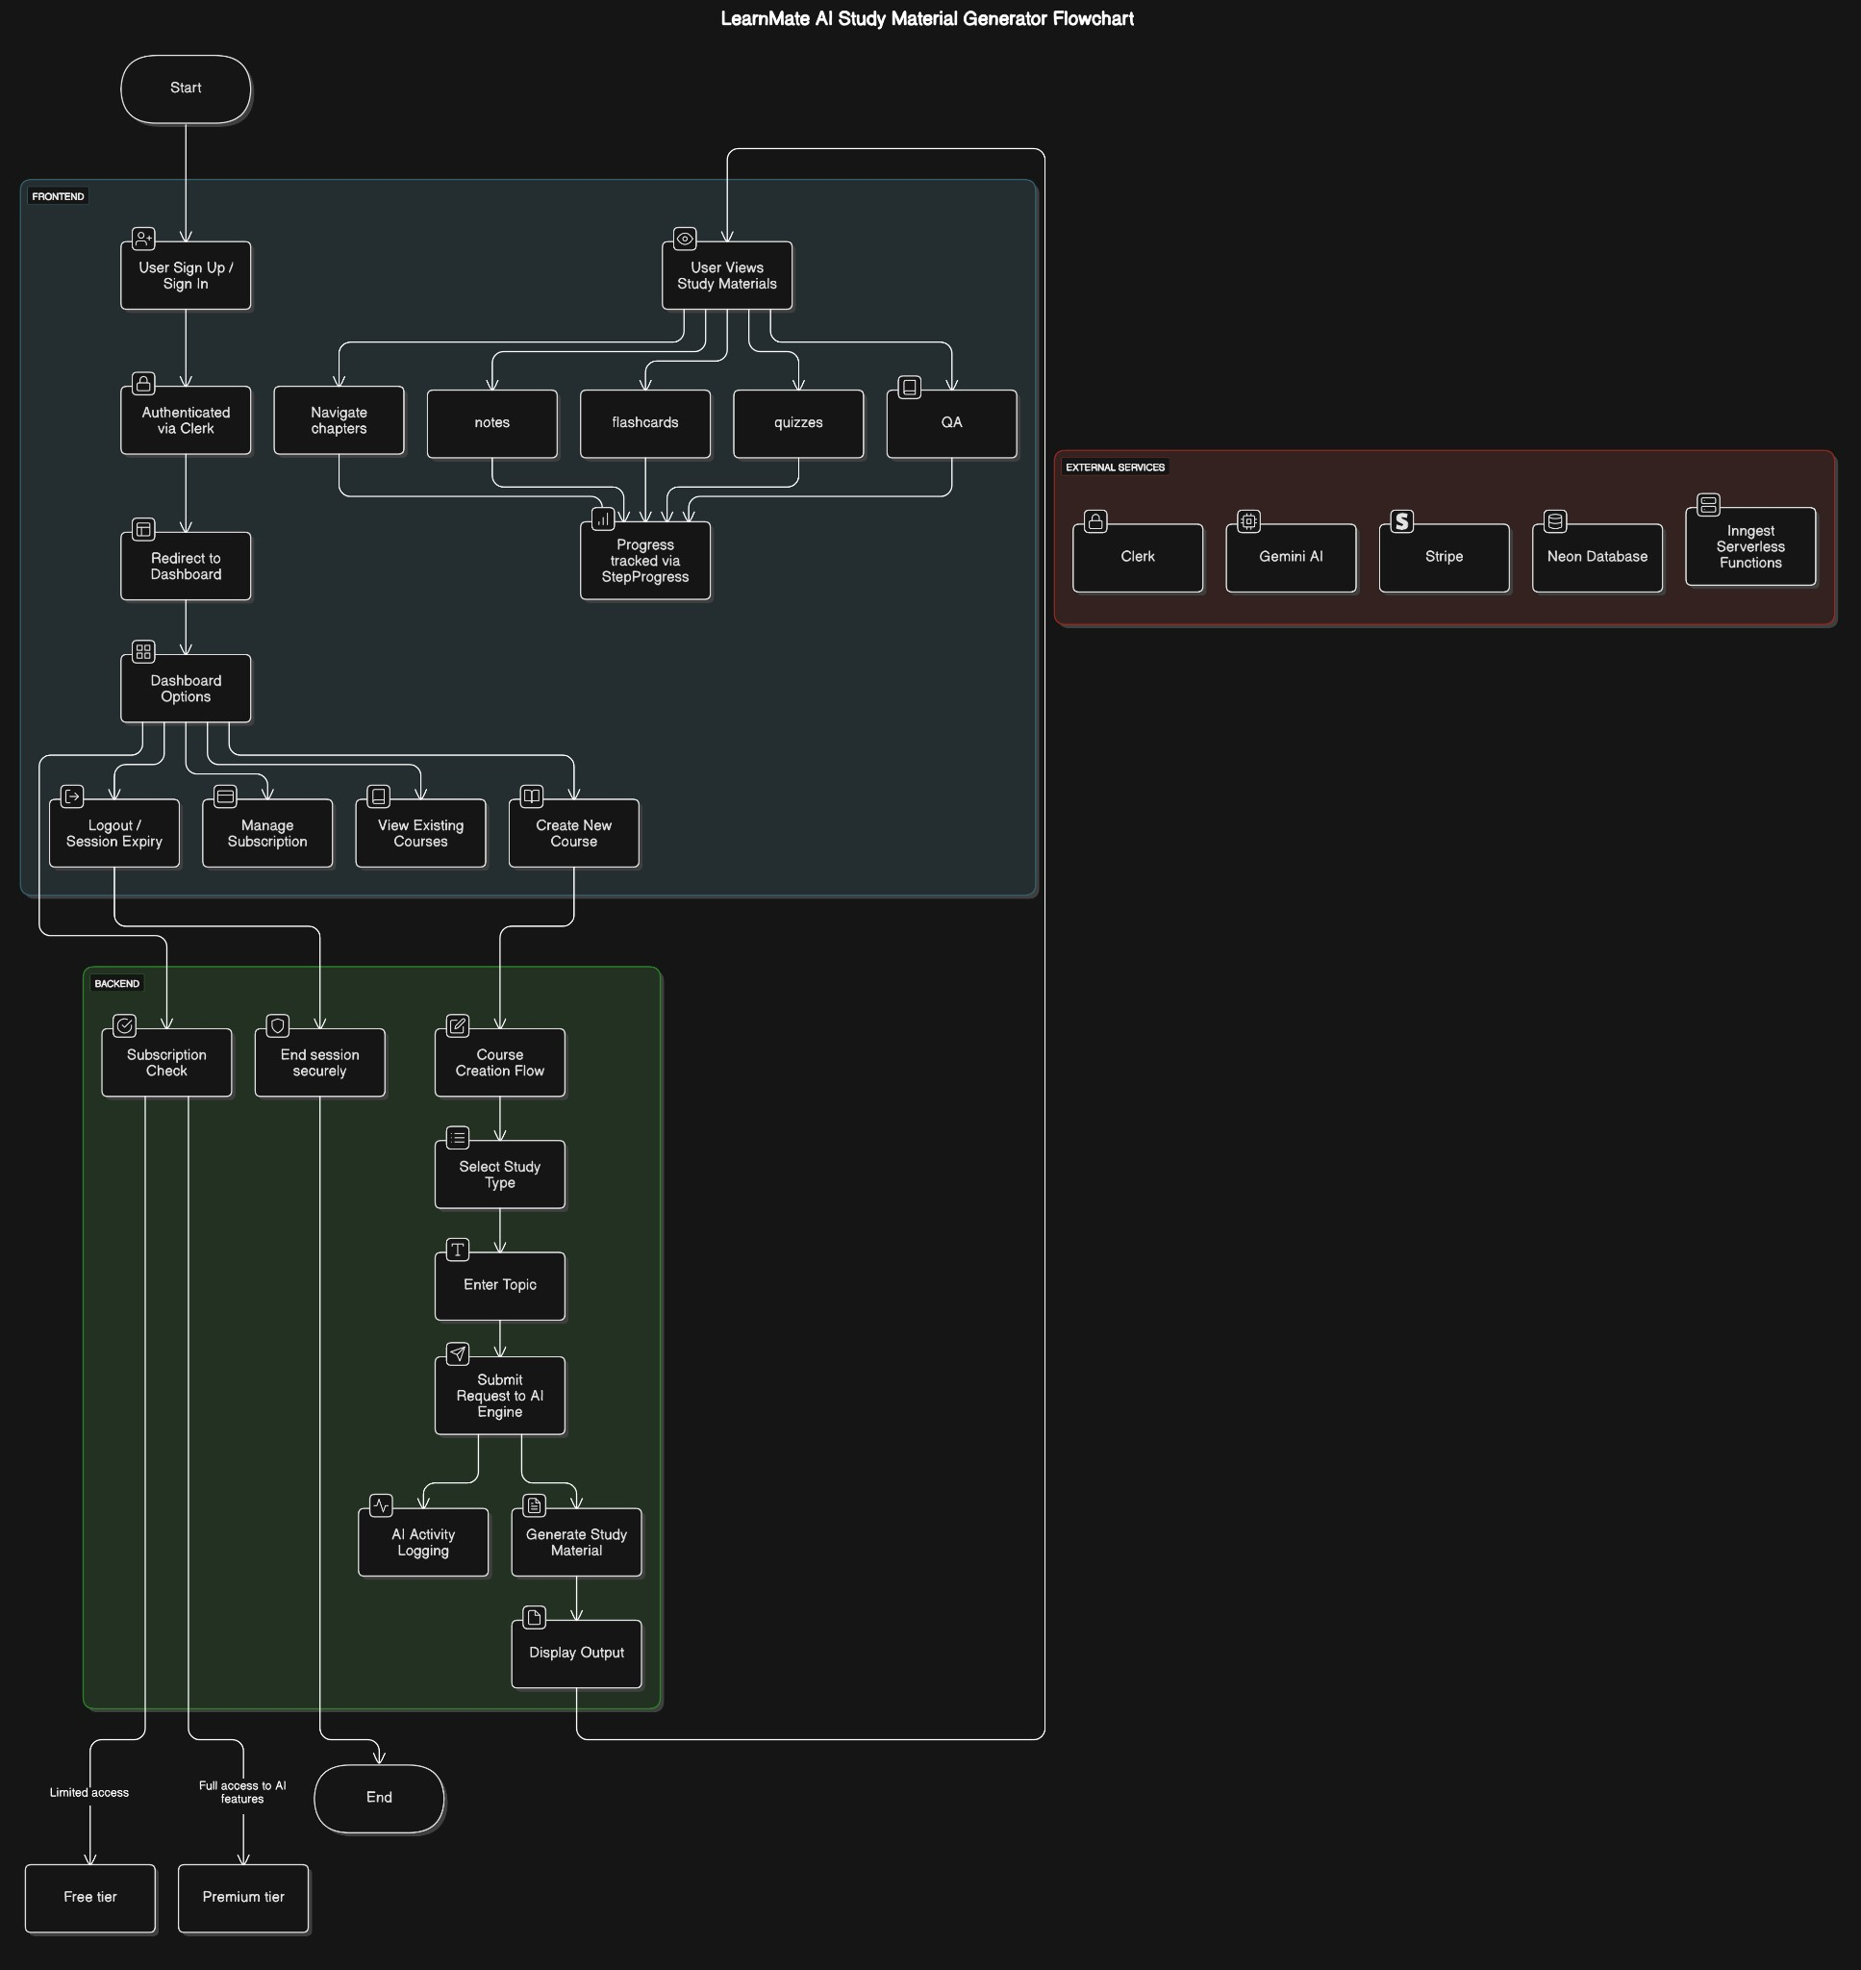

Fig No. 5.1

**1. FRONTEND USER FLOW (BLUE SECTION)**

This section represents the user’s interaction with the LearnMate platform — from signing up to viewing study materials.

**Step-1** Start → User Sign Up / Sign In

* Users begin by signing up or signing in using an authentication interface.
* Clerk is the service managing this process with built-in UI for login/signup.

**Step-2** Authenticated via Clerk

* Once verified, users are securely logged in.
* Clerk creates and manages user sessions (cookies/tokens) to maintain login state.

**Step-3** Redirect to Dashboard

* After login, users land on the main dashboard page, which presents various course-related options.

**Step-4** Dashboard Options

Users can do four major things:

1. Logout / Session Expiry
   * Ends user session securely using Clerk's built-in mechanisms.
2. Manage Subscription
   * Users can upgrade, cancel, or review their subscriptions via Stripe.
3. View Existing Courses
   * Previously created AI-generated courses are listed here for quick access.
4. Create New Course
   * Triggers the backend flow (green section) to generate a new course based on a user-provided topic.

**Step-5** User Views Study Materials

Once a course is created or selected, it shows:

* Notes (summarized AI content)
* Flashcards (Q&A styled memory tools)
* Quizzes (MCQs auto-generated by AI)
* Q&A (freestyle questions for deep understanding)

*All of these are generated via Gemini AI and pulled progressively via Inngest for better performance.*

Step-6 Progress / Study Logs

* Every action is logged to track user learning history and show analytics like "Progress Graphs" (not shown in flowchart, but inferred).

**2. BACKEND FLOW (Green Section)**

This is triggered when a new course is created. It involves user input, AI processing, and output generation.

**1. Subscription Check**

* Before allowing course generation, the system checks the user’s subscription tier:
  + Free tier → limited AI generations.
  + Premium → full access to all content types.

Done via Stripe subscription check.

**2. End Session if Not Subscribed**

* If the user is not eligible for content creation, session may redirect or restrict access (soft logout).

**3. Course Creation Flow Begins**

1. Select Study Type
   * Users choose what kind of material they want: Notes, Quizzes, Flashcards, or Q&A.
2. Enter Topic
   * Any subject or keyword like "Operating System", "DBMS", "Machine Learning", etc.
3. Submit Request to AI Engine
   * Backend routes the input to Gemini AI using a well-crafted prompt tailored to the selected study type.
4. Activity Logging
   * Every input/output cycle is logged for performance tracking and user history.
5. Generate Study Material
   * Gemini processes the prompt and returns study content.
   * Backend fetches it and stores it in Neon Database.
   * Using Inngest, long operations (like quiz generation) are handled in the background and streamed as they complete.
6. Display Output
   * Once ready, the study material is shown to the user on the frontend.

This progressive generation ensures a real-time feel — users see output as it’s generated without having to wait for all data.

**3. EXTERNAL SERVICES (Red Section)**

These are critical third-party tools that power LearnMate's features:

| **Service** | **Role** |
| --- | --- |
| Clerk | Authentication, session handling, user management |
| Gemini AI | Core AI that generates notes, quizzes, flashcards, and Q&A from prompts |
| Stripe | Payment gateway for subscription management |
| Neon DB | Serverless PostgreSQL DB for storing user data, AI results, logs, etc. |
| Inngest | Event-driven automation and background task runner |

**1. Output Flow & Ending**

Depending on the subscription tier:

* Free Tier Users get limited content types or limited requests.
* Premium Users access all tools, unlimited generations, and activity history.

Final state leads back to the Dashboard, enabling more actions or study sessions.

**Key highlights**

* Progressive Rendering: Users don't wait for the whole page to load; they see notes or flashcards appear as they’re generated.
* AI Personalization: Gemini generates context-aware content tailored to the input.
* Serverless Stack: All infrastructure is cloud-based, allowing fast scaling and no manual server maintenance.
* Modern UX: Authentication, dashboards, and analytics are managed via robust APIs.

### 5.2 Data Flow Diagram (DFD) Levels

#### 5.2.1 Level 0: Context Diagram

**Entities:**

1. User (Student / Institution)
2. Gemini AI
3. Clerk (Authentication Service)
4. Stripe (Payment Gateway)
5. Neon DB (Database)

**Process:**

* **LearnMate System** (single process node representing the whole application)

**Data Stores:**

*(Typically not shown in Level 0, but you can optionally mention Neon DB as a background database system.)*

**🧩 Data Flows:**

| **External Entity** | | **Direction** |
| --- | --- | --- |
| User | | → LearnMate |
| LearnMate | | → User |
| LearnMate | | ↔ Gemini AI |
| LearnMate | ↔ Clerk | |
| LearnMate | | ↔ Stripe |
| LearnMate | | ↔ Neon DB |

#### Diagram Representation:

**Fig No.5.2.1**

#### 5.2.2 Level 1: Detailed DFD

**Processes:**

* 1.0 handles user registration/login through Clerk.
* 2.0 connects with Gemini AI to generate content.
* 3.0 deals with managing and showing dashboards/courses.
* 4.0 manages payments via Stripe.
* 5.0 accesses/stores all relevant data in Neon DB.

**Data Stores:**

* D1: User Data
* D2: Course Content
* D3: Generated Study Materials
* D4: Payment Info

**External Entities:**

* User: initiates all requests.
* Clerk: authentication service.
* Gemini AI: generates AI-based content.
* Stripe: manages payment.

1. **Diagram Represenatation:**

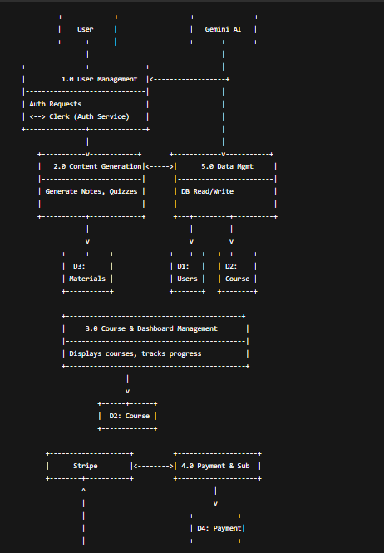

Fig No.5.2.2

**5.2.3 Level 2: Sub-Process Detail**

**Explanation of Processes**

| **Subprocess** | **Description** |
| --- | --- |
| **2.1 Input Topic & Preferences** | User provides the topic, study style, and level. |
| **2.2 Generate Course Outline** | Calls Gemini AI to structure an outline. |
| **2.3 Generate Materials** | Uses Gemini AI to create content like notes, quizzes, and flashcards. |
| **2.4 Store Generated Content** | Saves the output in the database (D3). |

**Data Stores:**

* **D2**: Contains course outlines and metadata.
* **D3**: Stores all generated learning materials.

**External Entity:**

* **User**: Initiates the content generation process.
* **Gemini AI**: Processes content generation logic via API.

#### Diagram Representation

**Fig No.5.2.3**

**5.3 Entity Relationship Diagram**

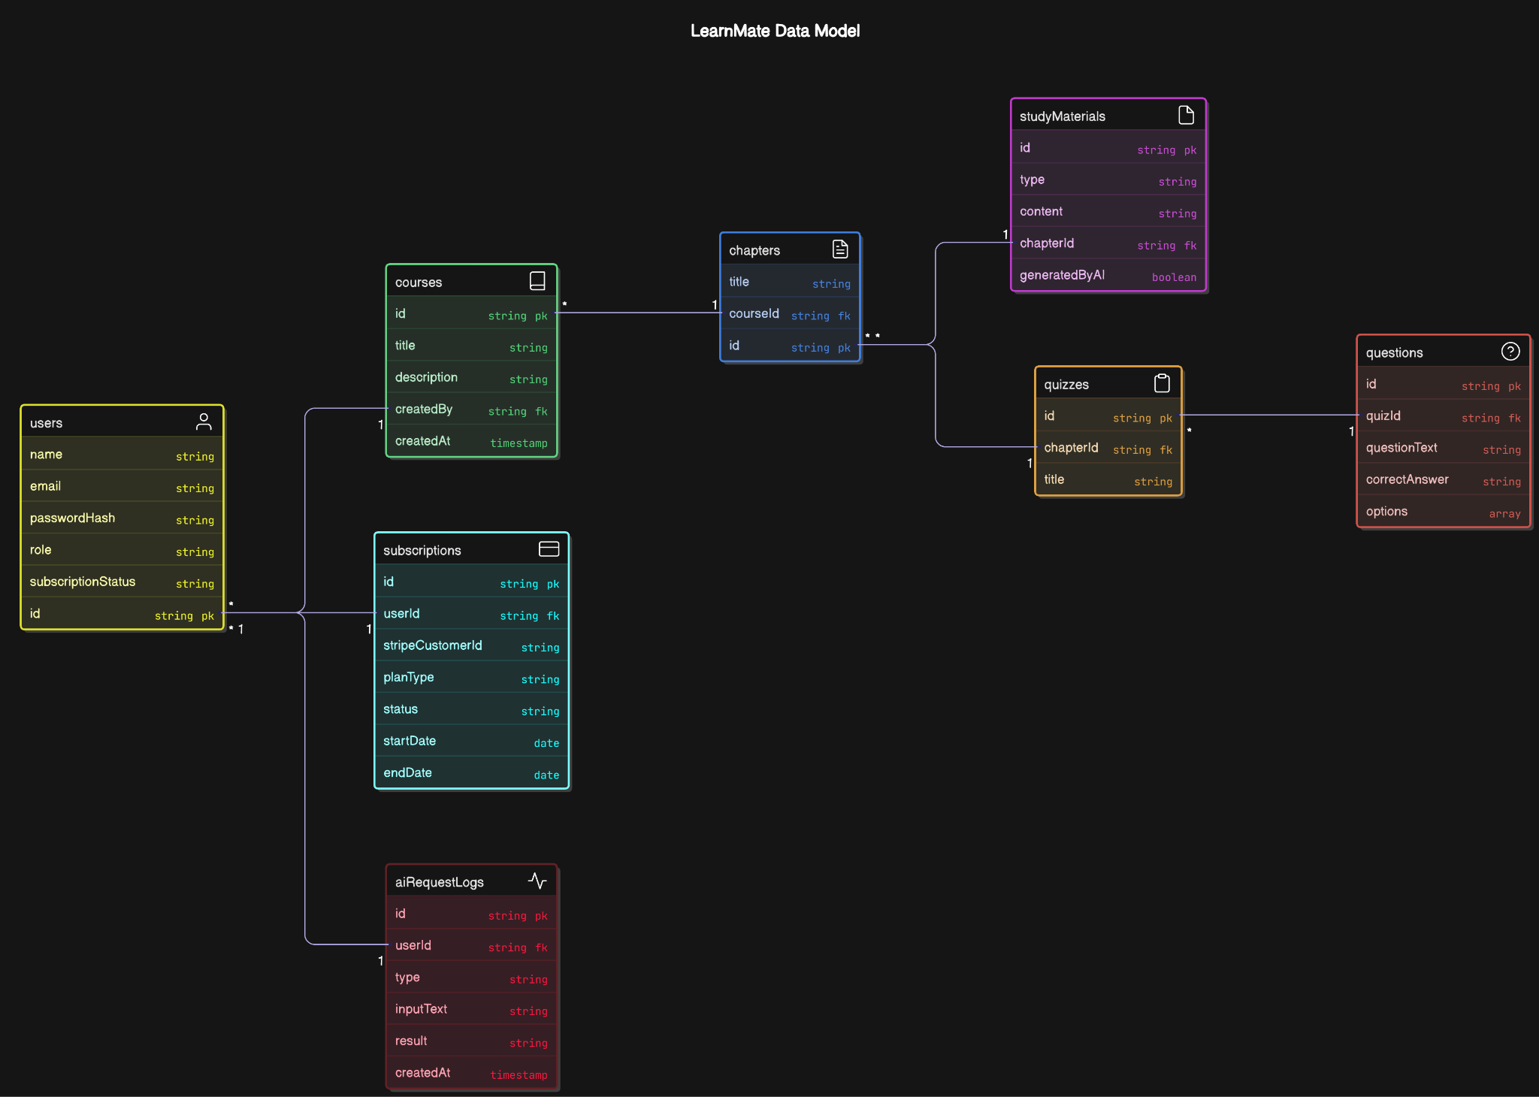

**Fig No.5.3**

An **ER Diagram** is a type of data modeling diagram that visually describes:

* The **entities** (like users, orders, products)
* The **relationships** between them (like one-to-many, many-to-many)
* The **attributes** of each entity (like name, email, etc.)

It’s used to design the **database schema** before implementation. It helps backend developers and database engineers understand:

* What data to store
* How the data relates
* How to structure the database efficiently

**Part 2: Detailed Explanation of the LearnMate ER Diagram**

Here’s an in-depth walkthrough of each entity and how they connect:

**1. users (Yellow)**

* This table stores information about every registered user.
* **Attributes:**
  + id: Primary Key – uniquely identifies a user.
  + name, email: User’s name and email.
  + passwordHash: Encrypted password.
  + role: Can be 'user', 'admin', etc.
  + subscriptionStatus: Status like active/inactive.

**Relationships:**

* Linked to:
  + subscriptions (1-to-1 or 1-to-many)
  + courses (1-to-many, as createdBy)
  + aiRequestLogs (1-to-many for AI usage tracking)

**2. courses ( Green)**

* Represents individual courses created by users.
* **Attributes:**
  + id: Primary Key
  + title, description: Name and details of the course
  + createdBy: Foreign Key (links to users)
  + createdAt: Timestamp of course creation

**Relationships:**

* One course can have **multiple chapters**
* Belongs to a **user** who created it

**3. chapters ( Blue)**

* Each course contains chapters.
* **Attributes:**
  + id: Primary Key
  + title: Chapter title
  + courseId: Foreign Key (linked to courses)

**Relationships:**

* A chapter belongs to one course
* A chapter can have:
  + quizzes
  + studyMaterials

**4. studyMaterials ( Purple)**

* These are the generated materials: notes, flashcards, Q&A, etc.
* **Attributes:**
  + id: Primary Key
  + type: e.g., 'notes', 'flashcard'
  + content: The actual study content
  + chapterId: Foreign Key
  + generatedByAI: Boolean – true if generated by AI

**Relationships:**

* Belongs to a chapter

**5. quizzes ( Orange)**

* Each chapter may have a quiz.
* **Attributes:**
  + id: Primary Key
  + title: Quiz title
  + chapterId: Foreign Key

**Relationships:**

* A quiz is tied to one chapter
* Can contain multiple questions

**🟥 6. questions (🟥 Red)**

* Stores questions for each quiz.
* **Attributes:**
  + id: Primary Key
  + quizId: Foreign Key
  + questionText: The question itself
  + correctAnswer: Correct option
  + options: Array of multiple-choice answers

✅ **Relationships:**

* Each question belongs to one quiz

**🟦 7. subscriptions (Cyan / Teal)**

* Tracks subscription info per user.
* **Attributes:**
  + id: Primary Key
  + userId: Foreign Key
  + stripeCustomerId: ID for Stripe integration
  + planType: 'free', 'premium', etc.
  + status: active/inactive
  + startDate, endDate: Billing period

✅ **Relationships:**

* Linked to a user (userId)

**🟥 8. aiRequestLogs (Dark Red)**

* Logs every AI prompt sent by the user for transparency and analysis.
* **Attributes:**
  + id: Primary Key
  + userId: Foreign Key
  + type: e.g., 'note-generation', 'quiz-generation'
  + inputText: User’s topic
  + result: AI’s generated output
  + createdAt: Timestamp

✅ **Relationships:**

* Tracks the activity of a single user

**🔗 Relationships Summary:**

| **Entity** | **Related To** | **Relationship Type** |
| --- | --- | --- |
| users | subscriptions | One-to-One / One-to-Many |
| users | courses | One-to-Many |
| users | aiRequestLogs | One-to-Many |
| courses | chapters | One-to-Many |
| chapters | studyMaterials | One-to-Many |
| chapters | quizzes | One-to-Many |
| quizzes | questions | One-to-Many |

**CHAPTER 6 : PROJECT OUTCOME**

The LearnMate project was designed to simplify and personalize the process of learning by generating AI-based study material. The outcomes of the project span across technical success, usability, innovation, and potential future scope.

**1. Functional Outcomes**

* AI-Powered Content Generation:
  + The system successfully integrates Gemini AI to generate notes, flashcards, Q&A, and quizzes based on user-input topics.
  + Real-time and asynchronous content generation ensures faster interaction with minimal waiting time due to the use of Ingest service functions.
* User Account Management:
  + Secure and scalable authentication through Clerk, allowing seamless sign-up, sign-in, and session management.
  + Role-based access allows for managing both free and premium user experiences.
* Subscription Handling:
  + Stripe integration enables payment handling and differentiates free-tier users from premium ones.
  + Admins and users can manage subscription status, see access levels, and view billing cycles.
* Course and Material Management:
  + Users can create multiple courses and chapters, each holding generated or manually added content.
  + They can view, edit, and manage content dynamically through an intuitive dashboard.

1. **Learning Outcomes (For Developers/Team)**

* Full-stack SaaS Application Development:
  + Hands-on experience building a Software-as-a-Service product from scratch.
  + Integration of frontend (Next.js), backend (APIs), AI (Gemini), and cloud database (Neon).
* Authentication & Authorization:
  + Learned to implement secure, scalable identity management using Clerk, including session management and protected routing.
* AI Integration & Optimization:
  + Understood how to interact with AI APIs effectively.
  + Learned how to optimize prompts and handle AI responses for real-time use cases.
* Database Design & ER Modeling:
  + Developed a normalized and scalable relational database using Neon.
  + Ensured smooth data flow between users, courses, chapters, and generated content.

1. **Technical Outcomes**

* Performance & Real-Time Feedback:
  + The use of Ingest allows content to stream progressively, enhancing user experience by delivering data chunk-by-chunk instead of waiting for complete responses.
* Scalability:
  + The modular design and usage of cloud-native services (like Neon DB and Clerk) ensure the system can scale as user demand grows.
* Security:
  + Password hashing, JWT-based session management, and secure payment flows are successfully implemented.
* Data Logging & Analytics:
  + All AI interactions are logged in the aiRequestLogs table for auditing, user tracking, and performance monitoring.

**4. Innovation and Uniqueness**

* Unlike static e-learning systems, LearnMate dynamically generates new, personalized content for each user.
* Hybrid AI + user content curation system creates a balance between automation and customization.
* Fast rendering of generated content makes the user experience smooth and responsive.

**5. Impact and Use Cases**

* Students: Can quickly revise topics using flashcards, quizzes, and Q&A tailored to their needs.
* Educators: Can create structured courses effortlessly and use AI-generated content as a base.
* Institutions: Can implement LearnMate as a platform to provide personalized learning resources.

**6. Future Scope**

* Add collaborative learning rooms for users to share and discuss generated content.
* Implement voice input and multilingual support.
* Use ML to analyze learning patterns and suggest content adaptively.
* Enable offline access and content export as PDFs.

**Final Statement**

LearnMate successfully delivers a powerful, AI-driven, user-centric platform for modern learners. It stands out by combining personalization, automation, and scalability—making learning more efficient, engaging, and intelligent.

**USER INTERFACE**

**"Purpose Selection" Page:**

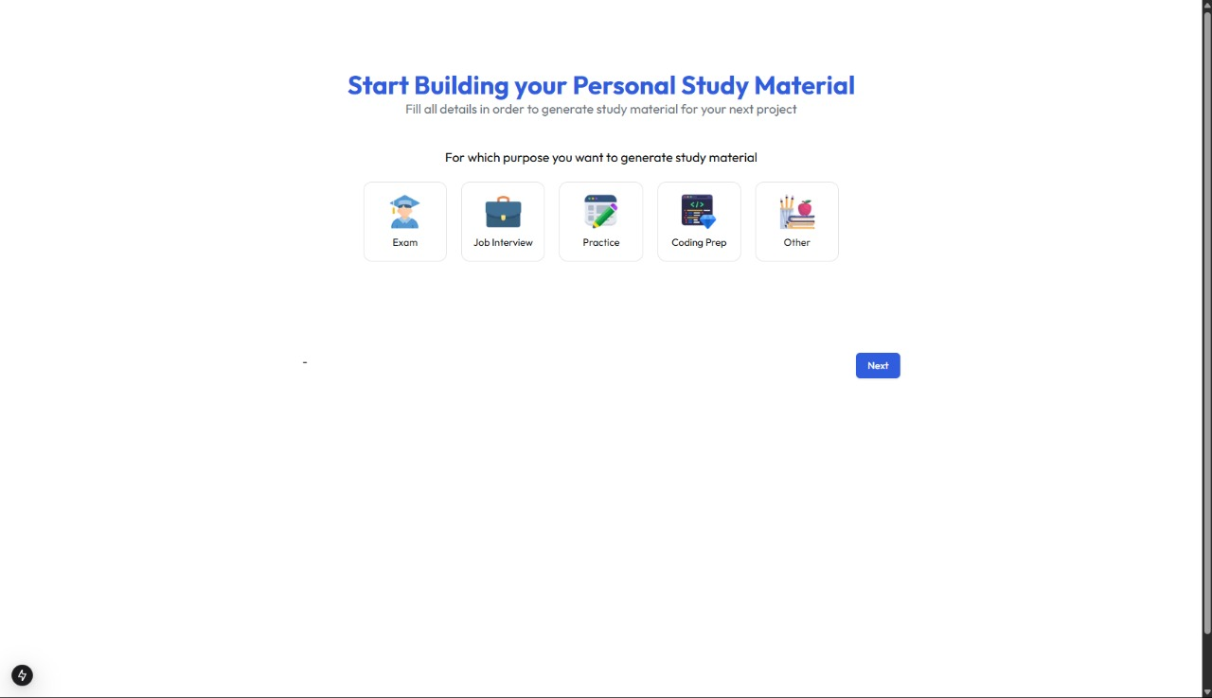

This web page is the first step of the study material generation process in the LearnMate application. It prompts users to select the purpose for which they want to generate study material—options include Exam, Job Interview, Practice, Coding Prep, and Other.

The page helps personalize the AI-generated content based on the selected goal. By understanding the user's purpose, the system can tailor the tone, format, and difficulty level of the study material, ensuring better relevance and learning efficiency.

**"Study Material Input Page":**

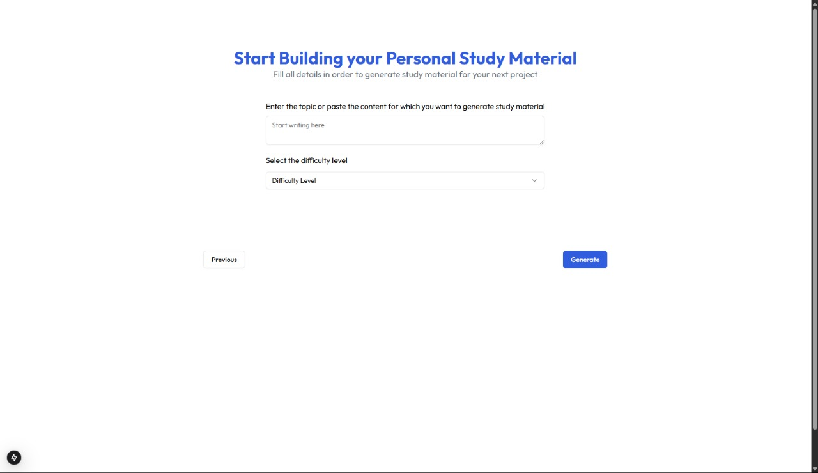

This web page allows the user to **input the topic** or **paste content** for which they want to generate personalized study material. The user can also **select a difficulty level** (e.g., easy, medium, hard) before clicking the **“Generate”** button to create the study content.  
This page collects **specific input and user preferences** (topic + difficulty) to generate AI-powered study material tailored to the user’s needs, such as for exams, practice, or job preparation.

**"Home Page":**

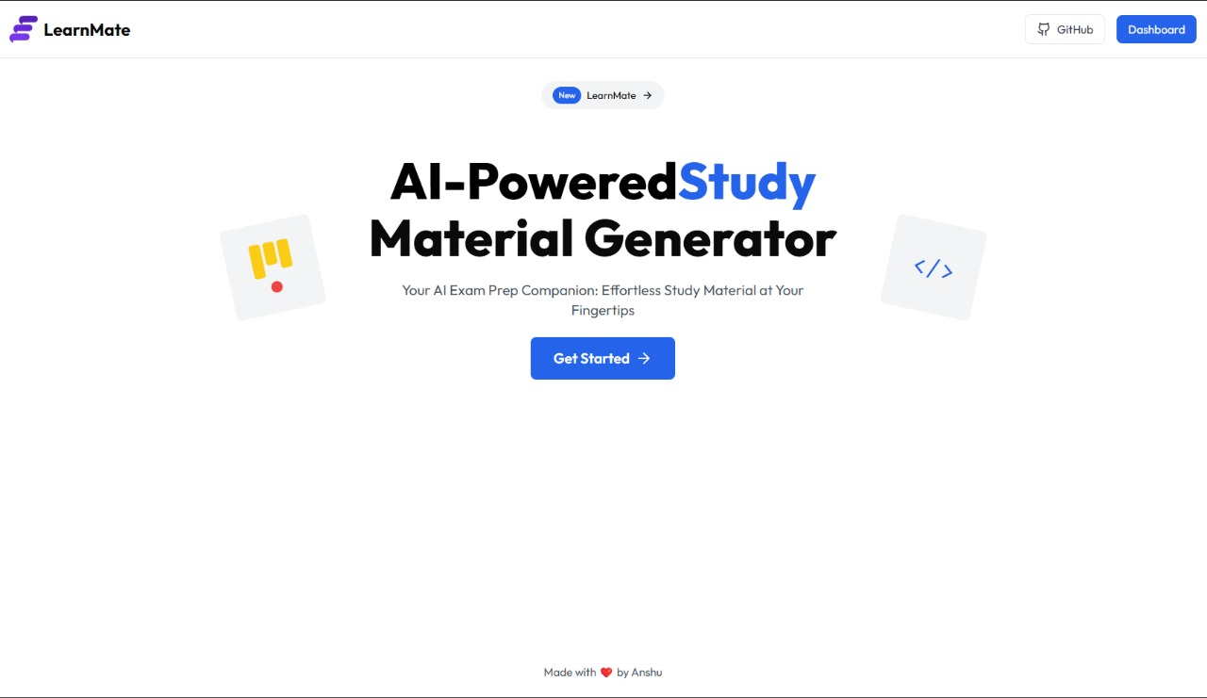

This is the landing page of a web application called LearnMate – an AI-Powered Study Material Generator. It introduces the platform and encourages users to begin generating personalized study content using artificial intelligence.

It serves as the homepage where users can learn about the platform's purpose and click on “Get Started” to begin generating customized study material for exam preparation.

**"Sign-In Page":**

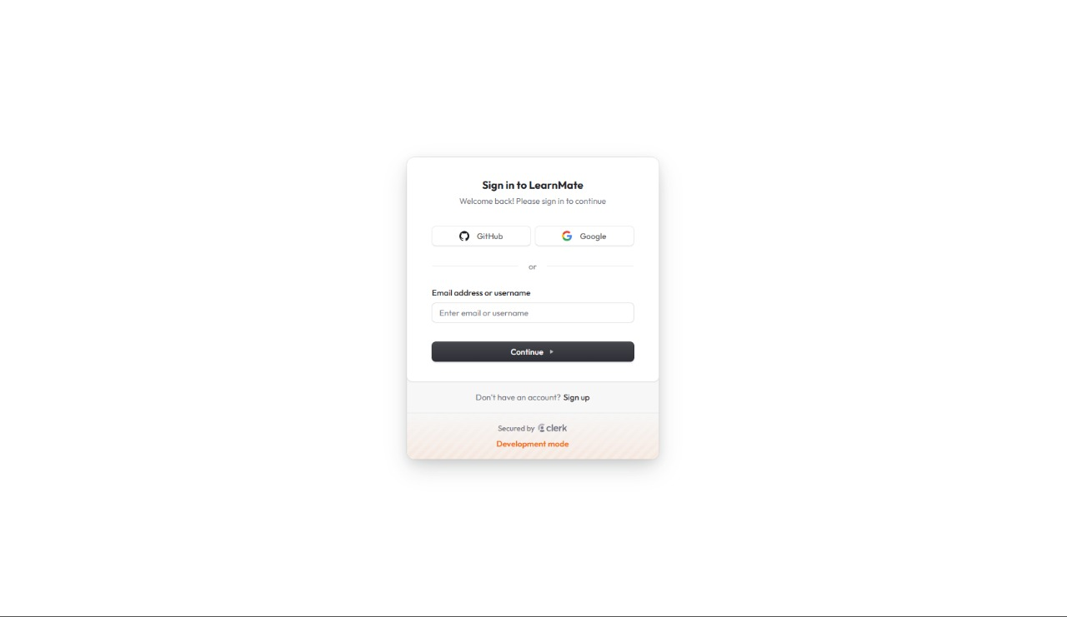

This is the Sign-In Page for the LearnMate application. Users can log in using GitHub, Google, or by entering their email address or username. There's also a link for users who don’t have an account to sign up.

It allows users to securely authenticate before accessing personalized features of the AI-powered study material generator.

**"Dashboard Page":**

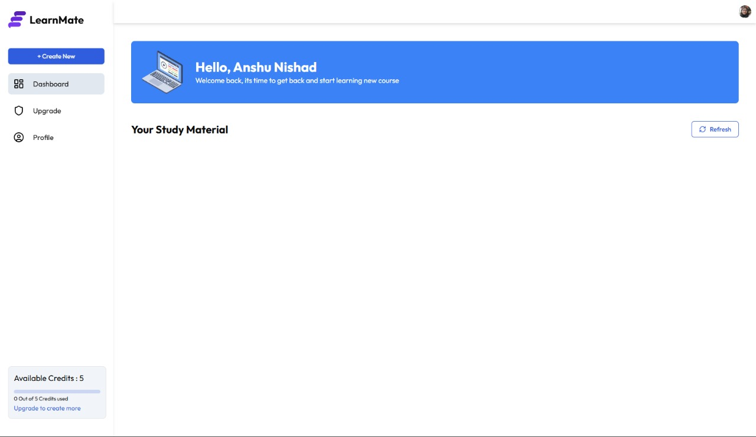

This is the Dashboard Page of the LearnMate application. After logging in, users are greeted with a welcome message and can see their study materials here. The dashboard includes options to Create New content, Upgrade the plan, or view the Profile.

Features on this Page:

* Welcome message personalized with the user's name (e.g., *"Hello, Anshu Nishad"*)
* Sidebar navigation with:
  + Create New button
  + Dashboard
  + Upgrade
  + Profile
* Display of available credits: *5 out of 5 credits unused*
* Refresh button to reload or sync study materials

**"Subscription & Pricing – LearnMate":**

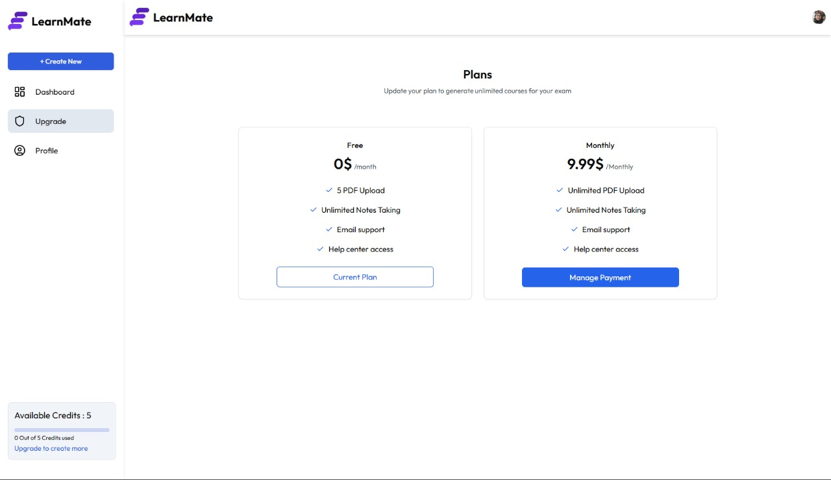

This is the Upgrade Page of the LearnMate application. It displays the available subscription plans, allowing users to switch between the Free and Monthly Paid plans.

Features on this Page:

* Title: Plans – with a subtitle encouraging users to upgrade.
* Two plan options:
  1. Free Plan (0$/month):
     + 5 PDF uploads
     + Unlimited note-taking
     + Email support
     + Help center access
     + Status: *Current Plan*
  2. Monthly Plan (9.99$/month):
     + Unlimited PDF uploads
     + Unlimited note-taking
     + Email support
     + Help center access
     + Action: *Manage Payment*
* Sidebar and credit indicator remain consistent with other pages.

**CONCLUSION**

The **LearnMate project** is a thoughtfully crafted educational platform aimed at making study material generation, note-taking, and academic preparation more accessible and effective for students. With a clean user interface and intuitive navigation, LearnMate bridges the gap between complex study tools and user-friendly experiences.

**Project Goals Achieved:**

1. **User-Centered Design:**
   * The interface focuses on ease of use, welcoming users with a friendly dashboard that encourages them to return and continue their learning journey.
   * Personalized touches like “Hello, [User Name]” help create a connection between the platform and its users, enhancing engagement.
2. **Efficient Dashboard and Course Management:**
   * The dashboard gives users a clear view of their study materials and allows for easy content refreshes and navigation.
   * The system provides an overview of available credits (usage), prompting timely decisions to upgrade if needed.
3. **Flexible Subscription Plans (Freemium Model):**
   * The **Free Plan** gives essential functionality (5 PDF uploads, unlimited notes), making it accessible for students with minimal needs.
   * The **Premium Plan** offers scalable features such as unlimited uploads, which are ideal for serious learners and long-term users.
4. **Scalable and Maintainable Codebase (Assumed from UI):**
   * From a development perspective, the UI suggests a modular structure that can easily integrate more features like AI-generated notes, flashcards, or even collaborative tools in the future.
5. **Encouraging Learning Habits:**
   * By showing users their progress, remaining credits, and by providing consistent support access, LearnMate encourages continuous learning behavior.

**What Makes LearnMate Stand Out:**

* **Minimalist & Clean Design:** Focuses user attention only on essential elements.
* **Smooth Freemium Transition:** Smart credit tracking and upgrade nudges.
* **User Motivation:** Encouraging messages and seamless workflow keep learners engaged.
* **Future-Proof:** The architecture supports potential expansion into more advanced features like quiz generation, gamified learning, or analytics-based insights.

**Final Thoughts:**

The LearnMate project successfully delivers a lightweight, accessible, and user-focused educational experience. It merges functionality with aesthetics to support both casual learners and dedicated students. With its current structure and user experience design, LearnMate holds strong potential for further scaling into a comprehensive ed-tech solution.

It’s not just a study tool—it’s a **learning companion**.

### REFERNCES

1. Google AI. (2024). *Gemini AI documentation*. <https://ai.google.dev/>
2. Clerk Inc. (2024). *Clerk: Authentication for React & Next.js*. <https://clerk.dev>
3. Stripe. (2024). *Stripe payments integration guide*. <https://stripe.com/docs>
4. Inngest. (2024). *Serverless event-driven functions documentation*. <https://www.inngest.com/docs>
5. Neon Inc. (2024). *Neon: Serverless PostgreSQL docs*. <https://neon.tech/docs>
6. Vercel. (2024). *Next.js documentation*. <https://nextjs.org/docs>
7. Tailwind Labs. (2024). *Tailwind CSS documentation*. <https://tailwindcss.com/docs>
8. Lucidchart. (2024). *What is a data flow diagram (DFD)?* <https://www.lucidchart.com/pages/data-flow-diagram>
9. Creately. (2024). *Data flow diagram symbols and guide*. <https://creately.com/guides/data-flow-diagram-dfd/>
10. Diagrams.net. (2024). *Draw.io diagram editor*. <https://app.diagrams.net>
11. Firebase. (2024). Firebase documentation. https://firebase.google.com/docs
12. MongoDB Inc. (2024). MongoDB manual. <https://www.mongodb.com/docs/manual/>
13. DigitalOcean. (2024). App platform documentation. https://docs.digitalocean.com/products/app-platform/
14. Postman. (2024). Postman API platform documentation. https://learning.postman.com/docs/getting-started/introduction/
15. Figma. (2024). Figma help center. https://help.figma.com/hc/en-us